Ex. No. : 07 | Date:
Register No.: 231701501 | Name: Sri Vishnu K

Decision Tree
Aim:
To implement Decision Tree algorithm for classification of the Iris dataset.
PROGRAM:
import pandas as pd
import numpy as np
import matplotlib.pyplot as plt

from google.colab import files
from sklearn.model_selection import train_test_split
from sklearn.preprocessing import LabelEncoder
from sklearn.tree import DecisionTreeClassifier, plot_tree
from sklearn.metrics import accuracy_score, confusion_matrix, classification_report

# Upload dataset
uploaded = files.upload()

# Load dataset
data = pd.read_csv("Iris.csv")

# Drop Id column if present
if 'Id' in data.columns:
data = data.drop('Id', axis=1)

# Split features and target
X = data.iloc[:, :-1].values
y = data.iloc[:, -1].values

# Encode target labels
le = LabelEncoder()
y = le.fit_transform(y)

# Train-test split
X_train, X_test, y_train, y_test = train_test_split(
X, y, test_size=0.2, random_state=42
)

# Create Decision Tree model
dt = DecisionTreeClassifier(random_state=42)

# Train model
dt.fit(X_train, y_train)

# Predictions
y_pred = dt.predict(X_test)

# Evaluation
accuracy = accuracy_score(y_test, y_pred)

print("Accuracy:", accuracy)
print("\nConfusion Matrix:\n", confusion_matrix(y_test, y_pred))
print("\nClassification Report:\n", classification_report(y_test, y_pred))

# Visualize Decision Tree
plt.figure(figsize=(12, 8))
plot_tree(dt, filled=True)
plt.title("Decision Tree Visualization")
plt.show()

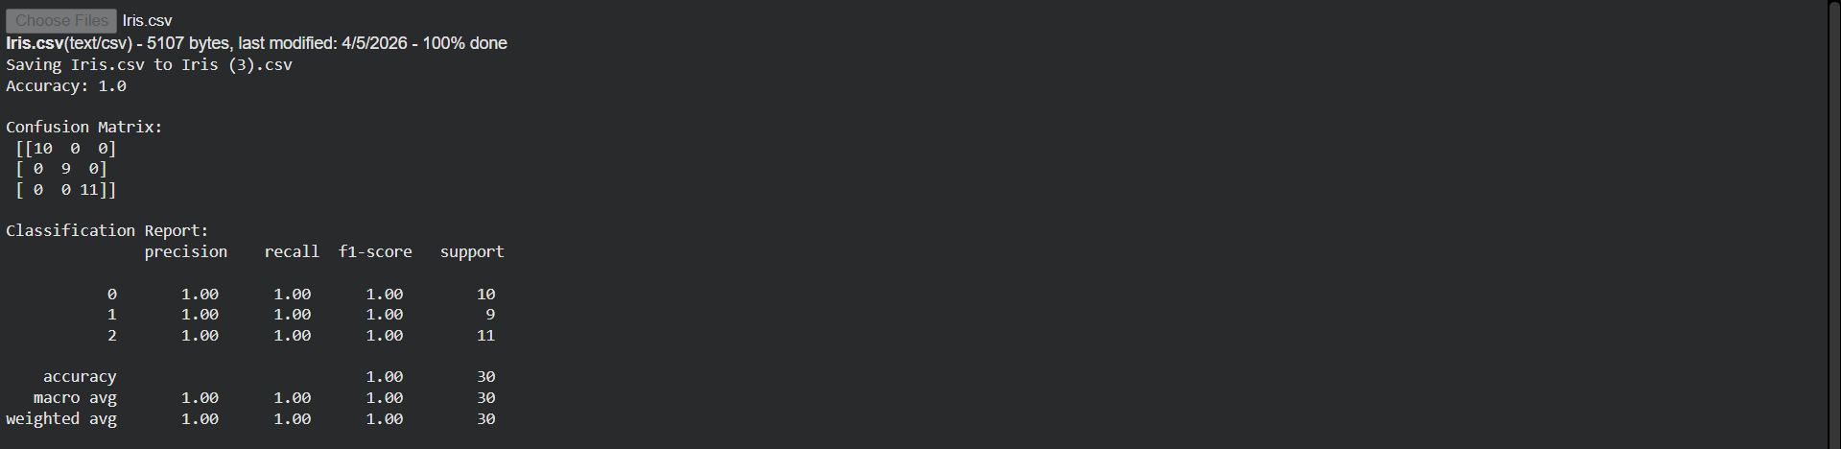

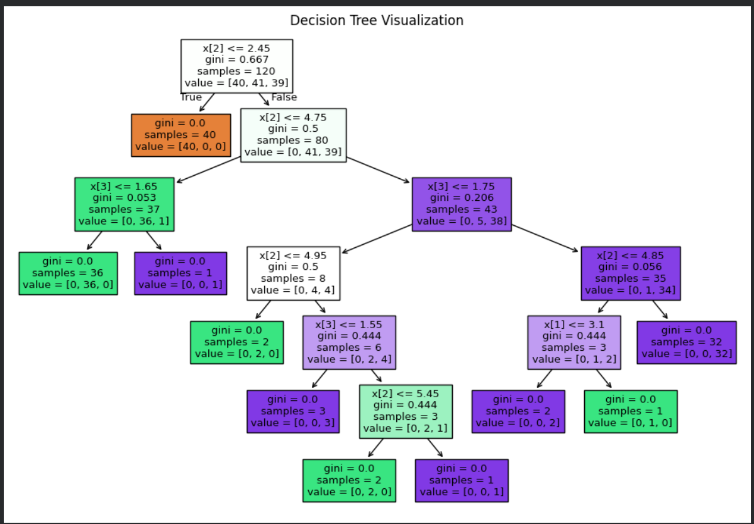

Result:
The Decision Tree model was successfully implemented and classified the Iris dataset accurately. The tree visualization clearly shows decision rules.

